|  |  |  |  |
| --- | --- | --- | --- |
| logo ngan.png | | **MINISTRY OF EDUCATION AND TRAINING** | |
| **FPT UNIVERSITY** | |
| **CAPSTONE PROJECT DOCUMENT** | |
| **BUILDING A WEBSITE SUPPORT THE ACTIVITIES “TIẾP SỨC MÙA THI” CAMPAIGN**  **Project Report #3 – System Requirements Specifications** | |
|  | |
| |  |  | | --- | --- | | **Group 22** | | | **Group Members** | |  |  | | --- | --- | | SE60769 | Nguyen Duy Khoa | | SE60687 | Le Nguyen Huu Tri | | 60358 | Nguyen Dinh Tuan | | 60325 | Tran Nguyen Kim Vinh | | 60339 | Nguyen Vinh Hien | | | **Supervisor** | Nguyen Trong Tai | | **Ext Supervisor** | N/A | | **Capstone Project Code** | TSMT | | |
| - Ho Chi Minh City, February 2014 - | |

Table of Contents

3. Software Requirement Specification 3

3.1. User Requirement Specification 3

3.1.1. Guest Requirements 3

3.1.2. Authorized User Requirements 3

3.1.3. Candidate Requirements 3

3.1.4. Charity Requirements 3

3.1.5. Volunteer Requirements 3

3.1.6. Sponsor Requirements 3

3.1.7. Admin Requirements 3

3.2. System Requirement Specification (Specific Requirements) 3

3.2.1. External Interface Requirements 3

3.2.2. Functional Requirements 3

3.2.3. Non-functional Requirements 3

3.3. Entity Relationship Diagram or Data Structure 4

3.3.1. Entity Relationship Diagram 4

3.3.2. Entity Detail 4

# SOFTWARE REQUIREMENT SPECIFICATION

## User Requirement Specification

### Guest Requirements

### Authorized User Requirements

### Candidate Requirements

### Charity Requirements

### Volunteer Requirements

### Sponsor Requirements

### Admin Requirements

## System Requirement Specification (Specific Requirements)

### External Interface Requirements

#### User Interfaces

#### Hardware Interfaces

#### System Interfaces

#### Communication Protocol

### Main Flow Overviews

### Functional Requirements

#### Overall Use case diagram

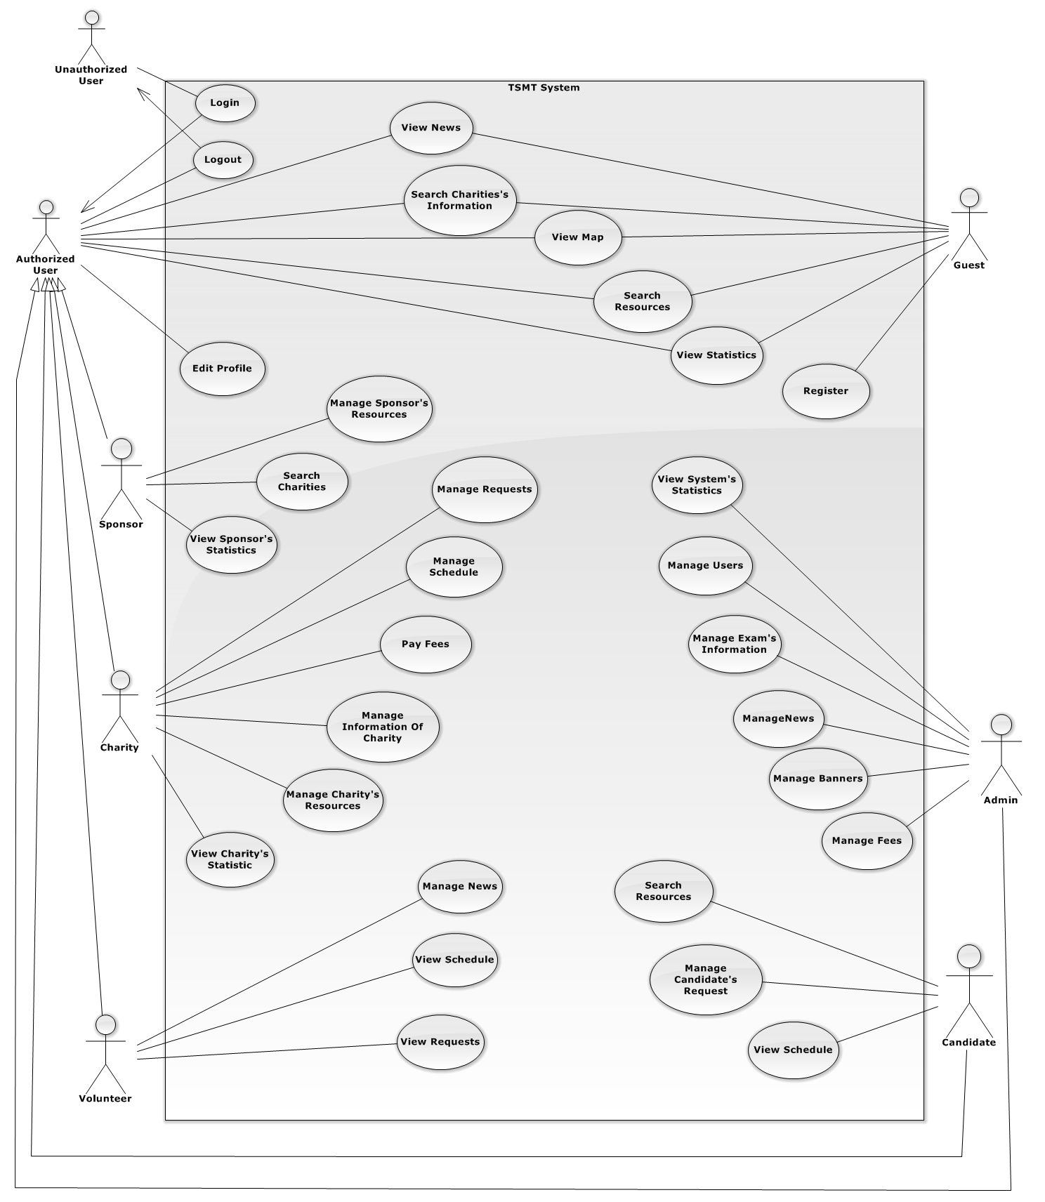

#### ⏪Unauthorized User⏩ Login

#### ⏪Authorized User⏩ View News

#### ⏪Authorized User⏩ Search Charity’s Information

#### ⏪Authorized User⏩ View Map

#### ⏪Authorized User⏩ Search Resource

#### ⏪Authorized User⏩ View Statistics

#### ⏪Authorized User⏩ Comment

#### ⏪Authorized User⏩ Edit Profile

#### ⏪Authorized User⏩ Logout

#### ⏪Guest⏩ Register

#### ⏪Guest, Authorized User⏩ Search Charity’s Information

#### ⏪Guest, Authorized User⏩ Search Resources

#### ⏪Guest, Authorized User⏩ View Map

#### ⏪Guest, Authorized User⏩ View News

#### ⏪Guest, Authorized User⏩ View Statistics

#### ⏪Charity⏩ Manage Charity’s Information

3.2.4.17.1 ⏪Charity⏩ Add Charity information

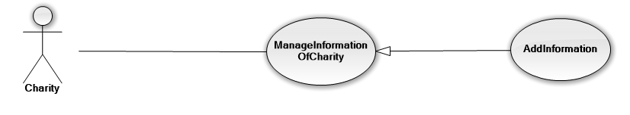

|  |  |  |  |  |
| --- | --- | --- | --- | --- |
| **USE CASE-06 SPECIFICATION** | | | | |
| **Use-case No.** | <UC06> | **Use-case Version** | | <1.0> |
| **Use-case Name** | Add Information of Charity | | | |
| **Author** | VinhTNK | | | |
| **Date** | 15/02/2014 | **Priority** | <Normal> | |
| **Actor:** Charity user.  **Summary:**Create new Charity’s information.  **Goal:**Create new Charity’s information*.*  **Triggers:**Want to add new Charity’s information.  **Preconditions:**Go to Charity page.  **Post Conditions:**New Charity’s information has been created.  **Main Success Scenario:**   |  |  | | --- | --- | | Actors action   1. Login with Charity account. | System Response | | 1. Enter Charity page. |  | | 1. Click on “Manager Exam Information”. 2. Click on “Add Exam Information” |  | |  | 1. Display screen to add Charity’s Information. | | 1. Fill all information of Charity. |  | |  | 1. Validate all input data. | | 1. Click on “Add” button. |  | |  | 1. Added new Charity’s information into Database and Reload page. |   **Alternative Scenario:** N/A  **Exceptions:** When database connection has problem, the system will ask user for trying again.  **Relationships:** N/A  **Business Rules:** N/A | | | | |

#### ⏪Charity⏩ Manage Request

3.2.4.18.1 ⏪Charity⏩ Make request

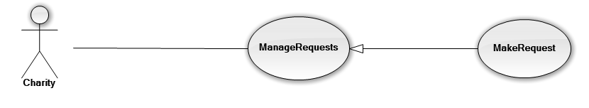

|  |  |  |  |  |
| --- | --- | --- | --- | --- |
| **USE CASE-07 SPECIFICATION** | | | | |
| **Use-case No.** | <UC07> | **Use-case Version** | | <1.0> |
| **Use-case Name** | Charity send to make a request. | | | |
| **Author** | VinhTNK | | | |
| **Date** | 15/02/2014 | **Priority** | Normal | |
| **Actor:** Charity user  **Summary:** This use case is about allowing charity to send request the system.  **Goal:** Send new request of Charity to system**.**  **Triggers**: Need to create new request.  **Preconditions:**   * Charity logon to the system * Go to Charity page   **Post Conditions:**   * Request of Charity is created and sent to system. * The sending request has Pending status.   **Main Success Scenario:**   |  |  | | --- | --- | | Actors action | System Response | | 1. Charity clicks on “New request” on menu. |  | |  | 1. Show “Manage Request” screen. | | 1. Charity fills required fields. |  | |  | 1. Validate all fields. 2. Send incorrect messages for each invalid field (if have). | | 1. Charity corrects all invalid fields (if have). 2. Charity clicks on “Send” button. |  | |  | 1. System will create new request with status Pending, send an email to admin and insert into Database. 2. Show successful message to Charity. |   **Alternative Scenario:** N/A  **Exceptions:**   * When database connection has problem, the system will ask user for trying again.   **Relationships:** N/A  **Business Rules:** Once Charity sent request but the admin has not approved or rejected, then candidate can delete that request. | | | | |

#### ⏪Charity⏩ Manage Resource

3.2.4.19.1 ⏪Charity⏩ Add new resource

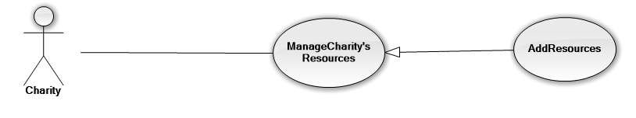

|  |  |  |  |  |
| --- | --- | --- | --- | --- |
| **USE CASE-08 SPECIFICATION** | | | | |
| **Use-case No.** | <UC08> | **Use-case Version** | | <1.0> |
| **Use-case Name** | Charity add new resource | | | |
| **Author** | VinhTNK | | | |
| **Date** | 15/02/2014 | **Priority** | <Normal> | |
| **Actor:** Charity user.  **Summary:**Create new resource.  **Goal:**Add resource into database*.*  **Triggers:**Want to add new resource information.  **Preconditions:**Go to Charity page.  **Post Conditions:**New resource information has been created.  **Main Success Scenario:**   |  |  | | --- | --- | | Actors action   1. Login with Charity account. | System Response | | 1. Enter Charity page. |  | | 1. Click on “Manage Resource”. 2. Click on “Add new resource” |  | |  | 1. Display screen to add new resource. | | 1. Fill all information of resource. |  | |  | 1. Validate all input data. | | 1. Click on “Add” button. |  | |  | 1. Added new resource information into Database and Reload page. |   **Alternative Scenario:** N/A  **Exceptions:** When database connection has problem, the system will ask user for trying again.  **Relationships:** N/A  **Business Rules:** N/A | | | | |

#### ⏪Charity⏩ Manage Schedule

3.2.4.20.1 ⏪Charity⏩ Add new schedule

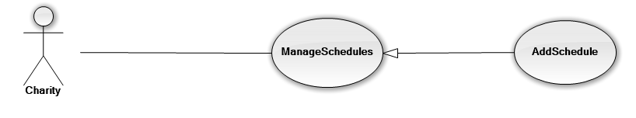

|  |  |  |  |  |
| --- | --- | --- | --- | --- |
| **USE CASE-09 SPECIFICATION** | | | | |
| **Use-case No.** | <UC09> | **Use-case Version** | | <1.0> |
| **Use-case Name** | Charity add new schedule | | | |
| **Author** | VinhTNK | | | |
| **Date** | 15/02/2014 | **Priority** | <Normal> | |
| **Actor:** Charity user.  **Summary:**Create new schedule.  **Goal:**Add schedule into database*.*  **Triggers:**Want to add new schedule information.  **Preconditions:**Go to Charity page.  **Post Conditions:**New schedule information has been created.  **Main Success Scenario:**   |  |  | | --- | --- | | Actors action   1. Login with Charity account. | System Response | | 1. Enter Charity page. |  | | 1. Click on “Manage schedule”. 2. Click on “Add new schedule” |  | |  | 1. Display screen to add new schedule. | | 1. Fill all information of schedule. |  | |  | 1. Validate all input data. | | 1. Click on “Add” button. |  | |  | 1. Added new schedule information into Database and Reload page. |   **Alternative Scenario:** N/A  **Exceptions:** When database connection has problem, the system will ask user for trying again.  **Relationships:** N/A  **Business Rules:** N/A | | | | |

#### ⏪Charity⏩ Pay Fees

#### ⏪Charity⏩ View Charity’s Statistics

#### ⏪Sponsor⏩ Manage Sponsor’s Resources

3.2.4.23.1 ⏪Sponsor⏩ Add new sponsor resource

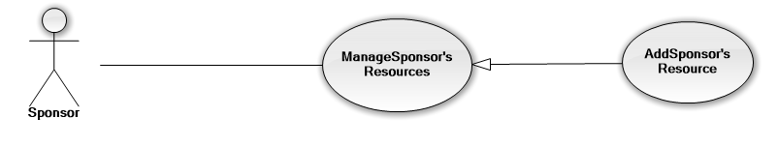

|  |  |  |  |  |
| --- | --- | --- | --- | --- |
| **USE CASE-10 SPECIFICATION** | | | | |
| **Use-case No.** | <UC09> | **Use-case Version** | | <1.0> |
| **Use-case Name** | Sponsor add new sponsor resource | | | |
| **Author** | VinhTNK | | | |
| **Date** | 15/02/2014 | **Priority** | <Normal> | |
| **Actor:** Charity user.  **Summary:**Create new sponsor resource.  **Goal:**Add sponsor resource into database*.*  **Triggers:**Want to add new sponsor resource information.  **Preconditions:**Go to Sponsor page.  **Post Conditions:**New sponsor resource information has been created.  **Main Success Scenario:**   |  |  | | --- | --- | | Actors action   1. Login with Sponsor account. | System Response | | 1. Enter Sponsor page. |  | | 1. Click on “Manage Sponsor resource”. 2. Click on “Add new resource” |  | |  | 1. Display screen to add new resource. | | 1. Fill all information of resource. |  | |  | 1. Validate all input data. | | 1. Click on “Add” button. |  | |  | 1. Added new resource information into Database and Reload page. |   **Alternative Scenario:** N/A  **Exceptions:** When database connection has problem, the system will ask user for trying again.  **Relationships:** N/A  **Business Rules:** N/A | | | | |

#### ⏪Sponsor⏩ Search Charity

#### ⏪Sponsor⏩ View Sponsor’s Statistics

#### ⏪Volunteer⏩ Manage News

3.2.4.26.1 ⏪Volunteer⏩ Add news

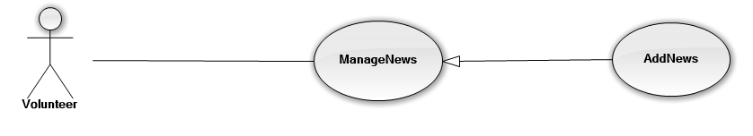

|  |  |  |  |  |
| --- | --- | --- | --- | --- |
| **USE CASE-11 SPECIFICATION** | | | | |
| **Use-case No.** | <UC11> | **Use-case Version** | | <1.0> |
| **Use-case Name** | Volunteer add News | | | |
| **Author** | VinhTNK | | | |
| **Date** | 15/02/2014 | **Priority** | <Normal> | |
| **Actor:** Volunteer.  **Summary:**Volunteer create news.  **Goal:**Create news*.*  **Triggers:**Want to create news.  **Preconditions:**Go to admin page.  **Post Conditions:**News has been created.  **Main Success Scenario:**   |  |  | | --- | --- | | Actors action   1. Login with Volunteer account. | System Response | | 1. Enter Volunteer page. |  | | 1. Click on “Manager News”. 2. Click on “Add News” |  | |  | 1. Display screen to add news. | | 1. Fill all information of that News. |  | |  | 1. Validate all input data. | | 1. Click on “Add” button. |  | |  | 1. Added new news into Database and Reload page. |   **Alternative Scenario:** N/A  **Exceptions:** When database connection has problem, the system will ask user for trying again.  **Relationships:** N/A  **Business Rules:** N/A | | | | |

#### ⏪Volunteer⏩ View Request

#### ⏪Volunteer⏩ View Schedule

#### ⏪Candidate⏩ Manage Candidate’s Request

3.2.4.29.1 ⏪Candidate⏩ Make request

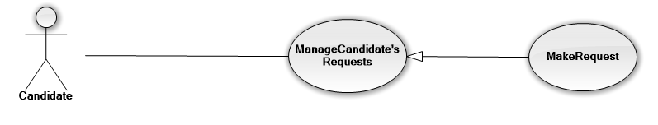

|  |  |  |  |  |
| --- | --- | --- | --- | --- |
| **USE CASE-05 SPECIFICATION** | | | | |
| **Use-case No.** | <UC05> | **Use-case Version** | | <1.0> |
| **Use-case Name** | Candidate send to make a request. | | | |
| **Author** | VinhTNK | | | |
| **Date** | 15/02/2014 | **Priority** | Normal | |
| **Actor:** Candidate user  **Summary:** This use case is about allowing candidate to send request for next examination.  **Goal:** Send request for lodge.  **Triggers**: Need to create new request.  **Preconditions:**   * Candidate logon to the system. The request includes some required information about:   + University   + Examination location   + Lodge expected   + Description   + When arrived   **Post Conditions:**   * Request of candidate is created and sent to system. * The sending request has Pending status.   **Main Success Scenario:**   |  |  | | --- | --- | | Actors action | System Response | | 1. Candidate clicks on “New request” on menu. |  | |  | 1. Show “Manage Request” screen. | | 1. Candidate fills required fields. |  | |  | 1. Validate all fields. 2. Send incorrect messages for each invalid field (if have). | | 1. Candidate corrects all invalid fields (if have). 2. Candidate clicks on “Send” button. |  | |  | 1. System will create new request with status Pending, send an email to admin and insert into Database. 2. Show successful message to Candidate. |   **Alternative Scenario:** N/A  **Exceptions:**   * When database connection has problem, the system will ask user for trying again.   **Relationships:** N/A  **Business Rules:** Once Candidate sent request but the admin has not approved or rejected, then candidate can delete that request.  Once Candidate has only one request in an examination. | | | | |

#### ⏪Candidate⏩ View Schedule

#### ⏪Candidate⏩ Search Resource

#### ⏪Admin⏩ Manage Advertising

3.2.4.32.1 Admin⏩ Add new banner

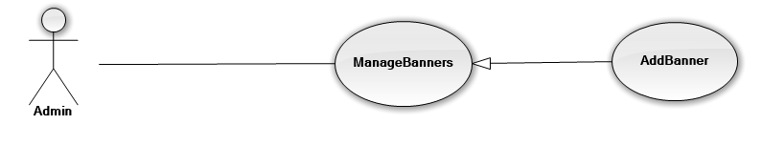

|  |  |  |  |  |
| --- | --- | --- | --- | --- |
| **USE CASE-01 SPECIFICATION** | | | | |
| **Use-case No.** | <UC01> | **Use-case Version** | | <1.0> |
| **Use-case Name** | Admin add Banner | | | |
| **Author** | VinhTNK | | | |
| **Date** | 15/02/2014 | **Priority** | <Normal> | |
| **Actor:** Admin.  **Summary:**Create new banner of website.  **Goal:**Create new banner of website*.*  **Triggers:**Want to create new banner.  **Preconditions:**Go to Admin page.  **Post Conditions:**Banner has been added.  **Main Success Scenario:**   |  |  | | --- | --- | | Actors action   1. Login with Admin account. | System Response | | 1. Enter Admin page. |  | | 1. Click on “Manager Banner”. 2. Click on “Add Banner” |  | |  | 1. Display screen to add new banner. | | 1. Choose banner image file. |  | |  | 1. Validate all input data. | | 1. Click on “Add” button. |  | |  | 1. Reload page. |   **Alternative Scenario:** N/A  **Exceptions:** Disconnect internet while upload new banner file.  **Relationships:** N/A  **Business Rules:** N/A | | | | |

#### ⏪Admin⏩ Manage Exam’s Information

* + - * 1. Admin⏩ Add new Exam information

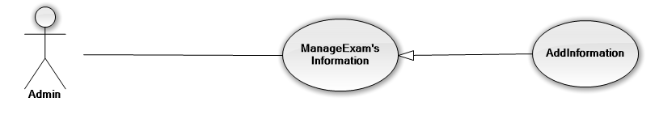

|  |  |  |  |  |
| --- | --- | --- | --- | --- |
| **USE CASE-02 SPECIFICATION** | | | | |
| **Use-case No.** | <UC02> | **Use-case Version** | | <1.0> |
| **Use-case Name** | Admin add Exam Information | | | |
| **Author** | VinhTNK | | | |
| **Date** | 15/02/2014 | **Priority** | <Normal> | |
| **Actor:** Admin.  **Summary:**Create new Exam information.  **Goal:**Create new Exam information*.*  **Triggers:**Want to create new exam information.  **Preconditions:**Go to admin page.  **Post Conditions:**Exam information has been created.  **Main Success Scenario:**   |  |  | | --- | --- | | Actors action   1. Login with Admin account. | System Response | | 1. Enter Admin page. |  | | 1. Click on “Manager Exam Information”. 2. Click on “Add Exam Information” |  | |  | 1. Display screen to add Exam Information. | | 1. Fill all information of that Exam. |  | |  | 1. Validate all input data. | | 1. Click on “Add” button. |  | |  | 1. Added new Exam information into Database and Reload page. |   **Alternative Scenario:** N/A  **Exceptions:** When database connection has problem, the system will ask user for trying again.  **Relationships:** N/A  **Business Rules:** N/A | | | | |

#### ⏪Admin⏩ Manage News

3.2.4.34.1 Admin⏩ Add news

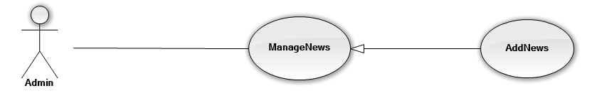

|  |  |  |  |  |
| --- | --- | --- | --- | --- |
| **USE CASE-03 SPECIFICATION** | | | | |
| **Use-case No.** | <UC03> | **Use-case Version** | | <1.0> |
| **Use-case Name** | Admin add News | | | |
| **Author** | VinhTNK | | | |
| **Date** | 15/02/2014 | **Priority** | <Normal> | |
| **Actor:** Admin.  **Summary:**Create news.  **Goal:**Create news*.*  **Triggers:**Want to create news.  **Preconditions:**Go to admin page.  **Post Conditions:**News has been created.  **Main Success Scenario:**   |  |  | | --- | --- | | Actors action   1. Login with Admin account. | System Response | | 1. Enter Admin page. |  | | 1. Click on “Manager News”. 2. Click on “Add News” |  | |  | 1. Display screen to add news. | | 1. Fill all information of that News. |  | |  | 1. Validate all input data. | | 1. Click on “Add” button. |  | |  | 1. Added new news into Database and Reload page. |   **Alternative Scenario:** N/A  **Exceptions:** When database connection has problem, the system will ask user for trying again.  **Relationships:** N/A  **Business Rules:** N/A | | | | |

#### ⏪Admin⏩ Manage User

3.2.4.35.1 ⏪Admin⏩ Add User

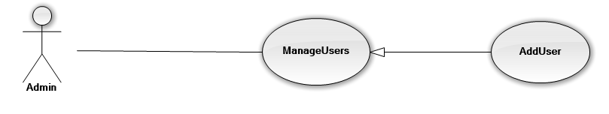

|  |  |  |  |  |
| --- | --- | --- | --- | --- |
| **USE CASE-04 SPECIFICATION** | | | | |
| **Use-case No.** | <UC04> | **Use-case Version** | | <1.0> |
| **Use-case Name** | Admin add new User | | | |
| **Author** | VinhTNK | | | |
| **Date** | 15/02/2014 | **Priority** | <Normal> | |
| **Actor:** Admin.  **Summary:**Create new user.  **Goal:**Create new users*.*  **Triggers:**Want to create new user.  **Preconditions:**Go to admin page.  **Post Conditions:**New user has been created.  **Main Success Scenario:**   |  |  | | --- | --- | | Actors action   1. Login with Admin account. | System Response | | 1. Enter Admin page. |  | | 1. Click on “Manager Users”. 2. Click on “Add User” |  | |  | 1. Display screen to add new user. | | 1. Fill all information of new user. |  | |  | 1. Validate all input data. | | 1. Click on “Add” button. |  | |  | 1. Added new user information into Database and Reload page. |   **Alternative Scenario:** N/A  **Exceptions:** When database connection has problem, the system will ask user for trying again.  **Relationships:** N/A  **Business Rules:** N/A | | | | |

#### ⏪Admin⏩View System Statistics

### Non-functional Requirements

#### Reliability

#### Availability

#### Security

#### Maintainability

#### Portability

#### Performance

## Entity Relationship Diagram or Data Structure

### Entity Relationship Diagram

### Entity Detail